Array

Array is a linear collection of similar elements. Array form an important part of almost all programming language. It provide a powerful feuture and can be used as or can be used to form complex data structures like stacks and queues.

One Dimensional Array

The one Dimensional array or single Dimensional array is the simplest type of array that contains only row for storing data. It has single set of square bracket[ ].

To declare single dimensional array, you can write the following code.

Ex : int a [ 5 ] ;

Where int is a data type of array.

‘a ‘ is name of array.

‘5’ is a number of elements in an array or size of array.

Note: The operator [] has two meaning in c language while declaring this means that represent the size of array, where as in other cases this [] operator means index/location of array element.

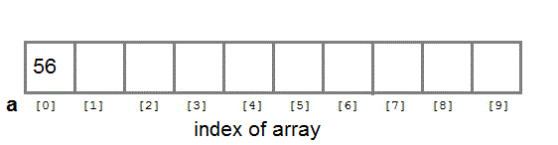

a [ 0 ] = 56 ;

Asssign statically value in an one dimensional array :

Ex:

int a [ 5 ] = { 9, 6 ,8 , 3 , 2 }

or

a [ 0 ] = 9 ;

a [ 1 ] = 6;

a [ 2 ] = 8 ;

a [ 3 ] = 3 ;

a [ 4 ] = 2 ;

Assign value through user in an one dimensional array

int a [ 1 ] ;

scanf ( “ %d ”, &a [ 0 ] ) ;

Note :

To storing and accessing the many no. of elements from one dimensional array you need to use loop in program.

The name of array contains base address of array. Ex : a

a[4] means *(a+4) (Prerequisite Pointer arithmetic)

value of a[4] is a value of *(a+4)

pointer we will cover later

Declaration of Array

int a[ ] ; //error

int a[ 5 ] ; //no error

int a[ ] = { 9 , 6 , 8 , 0 , 2 }; // by accessing over index than garbage value will return

int a[ 5 ] = { 9 , 6 , 8 , 0 , 2 } //no error

int a[ 5 ] = { 9 , 6 } // value 0 assign in remaining block

int a[ 2 ] ;

a[ 0 ]= 2 ; a[ 1 ]= 4 ; a [ 2 ]= 7 ; //No, error, you can also access extra initializer

int a[ 5 ] ;

a[ 0 ]= 9; // Garbage value assign in remaining block

or

assign value through user

int a[ 5 - 3] ; int a[ 5+1 ] ; int a[ 5%3 ] ; int a[ 3/2 ] ; int a[ 5*2 ] ;

Address of element in particular index in One Dimensional array is given by

A[i] = B + [i - L] * W

Where

B : Base Address

i : Index of Element or location to find

W : Size of Each Element

L : Lower Bound of Array / Starting Index.

Note : If Lower Bound or Starting index is not given in a question, we can assume it as 0.

Question 1:

Array given is A[7] //Size is given

Base Address : 2000 ( B = 2000)

Size of Each Address : 2 Bytes (W = 2)

Find Location A[5] = ?

Question 2:

A[-25 - - - - - +75] // Hint : Here Index is given

BA = 1000

W = 10 Bytes.

Find Loc A[60] = ?

Find No. of Elements in an Array.

Hint :

No. of Elements in One Dimensional array is given By = UB – LB + 1

Where UB : Upper Bound of Array

LB : Lower Bound of Array

Two dimensional Arrays

C language supports multidimensional arrays. The simplest form of the multidimensional array is the two-dimensional array.

Two-dimensional array is declared as follows,

type array-name[row-size][column-size]

Example :

int a[3][4];

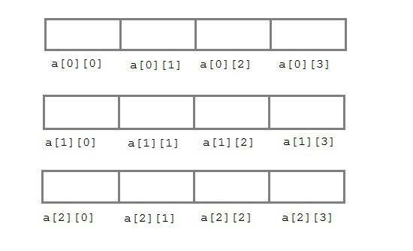

Asssign statically value in an array :

int arr[2][3] = { {0,0,0} , {1,1,1} };

Assign value through user in an array

int arr[3][4];

int i,j,k;

printf("Enter array element");

for(i=0;i<3;i++)

{

for(j=0; j < 4; j++)

{

scanf("%d",&arr[i][j]);

}

}

Multi Dimensional Array :

The MultiDimensional Array is such type of array that contains more than one row to store data on it. It can be two Dimensional array or three dimensional array or more.

To storing and accessing the elements from multidimensional array, you have need to use nested loop in program.

Example: int [3][2][3];

Implementation of Two Dimensional Array.

A two Dimensional Array can be implemented in a programming language in two ways.

Row Major Implementation

Column Major Implementation

Row Major Implementation :

Row major implementation is technique in which elements of array are reader from the keyboard row wise. The Complete first row is stored, then complete second row is stored and so on.

Example :

If we want to store Elements

10, 20, 30, 40, 50, 60 in an array a[2][3]
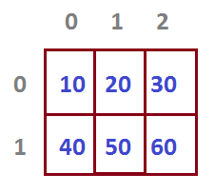

Address of an element in Particular index in Row Major Implementation

Address of Element a[i][j]

Formulae :

a[i][j] = B+[ ( i - Lr) n + (j- Lc)]*W ( For Row Major)

Where

B : Base Address

W : Size of Each Element

n : Number of Element on one row or number of column in an array(given by : Uc –Lc + 1)

L_{r} : Lower Bound of Row/ Starting Index of Row

L_{c} : Lower Bound of Column/ Starting index of Column.

U_{r} : Upper Bound of Row / Last index of Colum

U_{c} : Upper Bound of Column/ Last index of Column

Note: If Lower bound are not given in a question ,you can assume it as 0.

Column Major Representation/ Implementation

In Column Major Implementation memory allocation is done column by column i.e the complete first column is stored then the complete second column is stored and so on.

For Example : If we want to store elements.

10, 20, 30, 40, 50, 60 in an an array a[2][3]
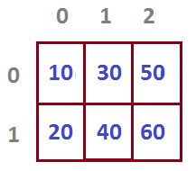

Address of Element in Particular index in Column Major Implementation

Address of Element a[i][j]

Formulae :

a[i][j] = B+[ ( i - Lr) + (j- Lc)m]*W ( For Column Major, Note m= Ur ­ Uc +1 )

Where

B : Base Address

W : Size of Each Element

m : Number of Element on one column or number of row in an array(given by : Ur –Lc + 1)

L_{r} : Lower Bound of Row/ Starting Index of Row

L_{c} : Lower Bound of Column/ Starting index of Column.

U_{r} : Upper Bound of Row / Last index of Colum

U_{c} : Upper Bound of Column/ Last index of Column

Note: If Lower bound are not given in a question ,you can assume it as 0.

Questions : On Row Major Order

Example :

A two Dimensional Array defined as a[4….7,-1….3]

Size of each element is 2 Bytes.
BA=1000

Find the address of location a[6,2]

Ans : 126

Example :

If each element of an array x[20][50] requires 4 bytes of storage ,base address of DATA is 2000. Determine the location of x[10][20] when the array is stored as Row Major Order.

Ans: x[10][10] = 4040

Example :

Consider a 2D array declared in “c” A[20][30]. Elements= type is integer. If the Base Address is 1076 , what will be the address of A[17][29] ? Memory is byte oriented.

Example

The array Data [10,15] is stored in memory in ‘Row major Order’, Base Address is 200 and element size is 1. Calculate the address of element data [7,12].

Ans: Data [7,12] is 317.

Example

Int a[4][4]

Size of each element = 2 byte

Base Address = 1000

Find loc = a[3][3] = ?

find loc a[2][3] = ?

Example :

A[25 … 79 , 55 … 124]

BA : 1000

W = 100 Bytes

Find Location A[55][75] = ?

Ans: 213000

Question : On Column Major Order

Example:

If each element of an array x[20][50] requires 4 Bytes of storage, base address of DATA is 2000. Determin the location of x[10][10] when the array is stored as Column majot Order.

Ans : 2840.

Example : A[4][4]

Base Address = 1000

W = 2 Bytes

Find Location at A[3][3] = ?

Example :

Each element of an array a[-20 … 20, 10 … 35] requires one byte of storage.If the array is column major implemented and Base Address is 500. Determin the address of element a[0][30].

Ans: 1340

